**Self-Directed Learning Tools in USAF Multi-Domain Operations Education**

Nathaniel Flack and Mark Reith

Department of Electrical & Computer Engineering, Air Force Institute of Technology, Dayton, USA

[nathaniel.flack@afit.edu](mailto:nathaniel.flack@afit.edu)

[mark.reith@afit.edu](mailto:mark.reith@afit.edu)

**Disclaimer:** The views expressed are those of the authors and do not necessarily reflect the official policy or position of the Air Force, the Department of Defense, or the U.S. Government.

**Abstract:** The United States Air Force (USAF) is aggressively pursuing transformation in the areas of Multi-Domain Operations (MDO) and enterprise education and training. The drive for these changes goes up to the highest levels of US Air Force and Department of Defense leadership motivated by a rapidly evolving world. These evolutions are forcing military organizations to rapidly and effectively educate personnel while adapting to new threats from multiple contested domains. To advance in these two areas required new information systems enabled by modern information technology to empower rich collaboration and innovation leveraging current operational experience and industry best practice. This paper explores the challenges facing MDO education in the 21st Century and defines elements of a potential solution drawing from Self-Directed Learning theory, proven commercial technology, and the new USAF Continuum of Learning construct. Extending the framework and cloud-based learning system created by the Air Force Institute of Technology called the Cyber Education Hub we propose a solution called the Multi-Domain Operations Hub. This new environment would enable content consumption, sharing, and creation as well as collaboration and innovation among members across all five warfighting domains (land, sea, air, space, and cyber) and all United States military branches. By utilizing the Topic Map and Knowledge, Skills, and Abilities Tree concepts integral to the existing Cyber Education Hub, the proposed solution will use the elements most attractive to Air Force functional communities while replacing cyber-specific elements with those relevant to MDO. The paper concludes by offering future research questions to inform the development and implementation of the MDO Hub while proposing a possible human subjects research experiment to test the effectiveness of the system.

**Keywords:** Multi-Domain Operations (MDO), Multi-Domain Command and Control (MDC2), US Air Force education and training, Self-Directed Learning (SDL), Cyber Education Hub™ (CEH™), MDC2 Card Game

**1. Introduction**

In the past two years the United States Air Force (USAF) has aggressively pursued innovation in two broad areas. The first, and most pressing, is a shift to a “Multidomain Operations (MDO)” mindset. The USAF Chief of Staff, General David Goldfein (2018) says this transformation is vital to prepare for future warfare “that will require [the US Military] to defend against and attack foes on land and sea as well as in the air, space and cyberspace.” Specifically, Goldfein is pushing the USAF to “master Command and Control of the multi-domain battle,” which is also referred to as Multi-Domain Command and Control (MDC2). The second area is an overhaul of its education and training paradigm, shifting from multi-month face-to-face programs to a more modular, agile, and on-demand structure. Given the size of the force and the complexity of the proposed changes, both of these initiatives will be largely unsuccessful without the utilization of innovative technology to provide elevated collaboration and engagement from members across the force. The 2018 US National Defense Strategy states, “Today, every domain is contested—air, land, sea, space, and cyberspace." Therefore, these transformations are vital to the future success of America’s military in future conflicts.

When he was appointed to his current position in 2016, Goldfein made Command and Control (C2) in a multi-domain context one of his top three priorities. He wrote, “The changing national security environment also requires us to examine who we sense, decide, and act rapidly and in concert across all domains – or to put it another way, master command and control of the multi-domain battle” (Goldfein, 2017). His message to all Airmen and the defense industrial and technological base is that the dominance the USAF enjoys today in the air, space, and cyber domains is not good enough. All the capabilities in these domains must be integrated, along with the sea and land domains, to create new and dramatic effects. Alberts and Hayes (2006) write, “New C2 Approaches are the fulcrum of an Information Age transformation of the Department of Defense (DoD) and understanding Command and Control is among the most important and urgent tasks we have on the critical path to transformation and the ability to meet 21st century mission challenges.” In a recent December 2018 article, Goldfein again highlighted the need for a shift to a multi-domain mindset ensuring future technology to be able to quickly gather information from multiple domains and then “just as quickly direct military actions will have the decisive advantage in battle.”

At the same time, many have called for changes to military education and training strategies. The former Secretary of Defense, James Mattis, is one of these voices. He emphasizes that the US Armed Forces need to “be prepared to deal with technological, operational, and tactical surprise, which requires changes to the way we train and educate our leaders and our forces…” (Mattis, 2017). Air Education and Training Command (AETC), the USAF’s Major Command dedicated to recruiting, training, and educating its members, is responding to these calls by transforming the way they think about education and training and forging new information technology tools to support that transformation. Given the push for more MDC2 innovation, from leaders like the Secretary of the Air Force, Heather Wilson, changes in education and training should focus on creating a system to facilitate MDO collaboration and develop innovative solutions.

Another key leader in the MDC2 arena is Col Jeffry Burdett, the 505th Training Group commander. Shortly after leading one of the first major MDC2 exercises in 2017 stated, “The [US] Air Force needs a mechanism for tracking operational-level C2 experience” (Caputo, 2017). This represents another angle of MDO that could be fulfilled by the innovative use of technology.

In summary, USAF leadership is asking for solutions that will advance the ball on MDO by providing innovative and relevant solutions engineered through collaboration of a diverse team while tracking MDC2 expertise across the force. In response, this paper proposes a potential solution that extends a prototype learning environment for cyber education currently under development at the Center for Cyberspace Research (CCR) at the Air Force Institute of Technology (AFIT) tailoring it for MDO education. The new learning environment will fuse innovative ideas from all levels of the force, lessons learned from real-world experience, and the vision of current and future leaders to shape MDO and C2.

**2. Describing the Current Challenges**

In an article titled “Rethinking USAF Cyber Education and Training” (Reith et al., 2018), describe the current challenges involved in cyber education in the US military. In response to these challenges they proposed a framework and technical solution focused on organizing crowd-sourced content from a variety of functional communities on a cloud enabled platform. They called this prototype the Cyber Education Hub™ (CEH™). Their framework was created to address significant challenges in the realm of cyber education. First, the ubiquity of cyber in every functional community creates a “scalability and breadth problem.” Cyber education needs to reach to all users, but also contain information specific to their functional community. Second, because cyber is a man-made and man-manipulated environment, it changes at a higher rate than other science and technology fields, creating a “currency problem.” Third, the size and interconnected nature of cyber leads to a “complexity problem.”

To varying degrees, MDO and MDC2 education face the same challenges as the cyber domain. First, MDO is inherently broad covering military operations in land, sea, air, space, and cyber. Education solutions must leverage resources, knowledge, and experience from every warfighting domain and make it available to the rest of the DoD. This requires a connection between all learners across various domains also creating a scalability and breadth problem. At a basic level, forces that want to integrate to achieve a common goal must know the general capabilities of each and commanders over multi-domain forces need to know the capabilities under their control to know how best to employ them. Second, MDO must be able to adapt quickly to new information, also creating a currency problem. Goldfein writes, “The changing national security environment also requires us to examine how we sense, decide, and act rapidly and in concert across all domains.” Because the operations themselves must be adaptable and broadly coordinated, education methods to teach these principles must also be ready to change as new information surfaces. Last, the interweaving of capabilities from multiple domains with personnel from many organizations, including national partners and coalitions, produces immense complexity. MDO requires warfighters who understand and execute their function when needed, but also know how they fit into the broader mission so that they can integrate effectively and innovate when necessary without creating unnecessary risk. Harris (2018) attests, “Planners and operators of one domain must have not only the skills to perform their own missions, but they must also understand how planners and operators of other domains assure or even challenge their mission accomplishment.”

In addition to these three challenges, specific characteristics of MDO need to be considered when designing an appropriate education system. First, in the US Military, MDO is vaguely defined. It is a nebulous term that will require the community to define and redefine as understanding and practice evolve. Developing such a definition requires space where ideas can be formulated and then evaluated in such a way that the best ones rise to the top. This characteristic also necessitates the incorporation of lessons learned from the operational communities on the front lines of Multi-Domain conflict to ensure that educational content is not divorced from real-world operations. Second, MDO education must facilitate learning by integrate differing communities effectively. MDO contributors will intrinsically have different backgrounds, which must be valued in the MDO context. However, a common operational lexicon must be established to enable communication and collaboration between various organizations and even nations. Therefore, unique approaches are needed to identify domain-specific and domain-agnostic terms and highlight them throughout the content. For example, each warfighter will need to learn the basic terms used in all other domains and express their domain’s capabilities in a way that is understandable by all. Finally, MDO education requires a combination of theory and practice. It is not sufficient to only discuss solutions, but an environment is needed where ideas and strategies can be tested and refined. Interactive content is needed that engage participants to explore MDO in order to discover pitfalls and identify winning approaches.

These challenges must be met with innovative solutions to transform three key areas: (1) the way people think, (2) the processes used to execute defensive and offensive operations, and (3) the technology used across a wide spectrum of applications. In part, the current transformations in USAF education and training is moving toward a solution.

**3. Lifelong Learners and USAF Education**

Through a construct called the Continuum of Learning (CoL), AETC is transforming the way that Airmen will conduct education and training. Roberson and Stafford (2017) describe how the CoL will move learning from the classroom to where it is needed right now, where the mission is executed. This means a shift away from instructor-led learning to self-learning and online courses. According to AETC’s leadership, the overall goal of these efforts is to create learning effectiveness by encouraging and supporting life-long learning. Figure 1 depicts the concept of AETC’s Learning Ecosystem explained by Lt Gen Roberson and Dr. Stafford in their description of the CoL.

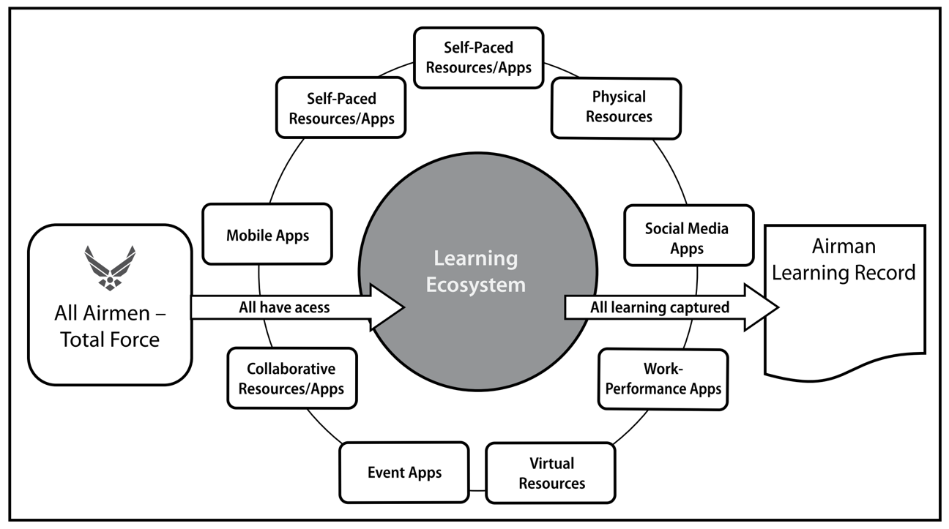

**Figure 1.** The USAF Learning Ecosystem envisioned by Roberson and Stafford (2017).

The CoL will change the way the USAF approaches education and training by providing modularized, blended, competency-based learning that can be either mandated by a training authority or accessed by the learner “on-demand”. Furthermore, the Learning Ecosystem will track an individual’s learning experiences serving as the centralized record of what an Airmen knows and what he or she can do. More information and explanation are provided in Roberson and Stafford (2017).

The change to focus on producing lifelong learners will advance both MDO and cyber education. However, another shift is needed away from Airmen consuming content based on mandated timelines to a Self-Directed Learning (SDL) model where individuals are empowered to take control of their own learning. This kind of shift, engendered in the CEH and other commercial systems, have the best shot at producing large numbers of warfighters who can both execute the mission today and adapt to overcome future challenges.

SDL, a term coined by Knowles in the 1960s, describes a method of learning that puts the responsibility for learning on the shoulders of the learner. Knowles (1975) writes, in SDL “individuals take the initiative, with or without the help of others, in diagnosing their learning needs, formulating learning goals, identifying human and material resources for learning, choosing and implementing learning strategies and evaluating learning outcomes” (As quoted in Hase and Kenyon, 2000). Hase and Kenyon (2000) take Knowles’ analysis a step further by focusing on self-determined learning across the spectrum of the education and learning lifespan. Their analysis also takes into the rapidly changing world where learning needs to be immediate and learning methods must be flexible.

MDO education needs to encourage students to become self-directed learners in order to take advantage of the speed of collaboration and innovation produced by modern technology, especially social media and the Web 2.0 revolution, typified by the speed of information exchange. This technology offers any organization the ability to effectively deliver education and training on a grand scale and create agile tools to provide rich collaboration and innovation.

**4. SDL in Military Education and Training**

The military is facing the same challenges as the wider world stemming from digital transformation and interconnectivity which complicates military communities, work centers, and battlefields. The application of the principles of SDL should be a key consideration in growing a military force ready to operate in a 21st century environment. However, there are several aspects of SDL that will require evaluation and testing before implementation in the military.

America is very proficient at training warfighters to succeed in operational contexts that are well-known and relatively predictable. Through repetition and discipline, military members are taught how to fight according to well-established tactics, techniques, and procedures. The military should not discard this training and discipline but should emphasize it throughout a warfighter’s training. In this context, SDL models will seem to work against the current culture in military environment where reproduction is highly valued. In almost all US military organizations each member can fill multiple roles so that the mission continues despite losses. This is necessary for conducting military operations in a wartime environment and requires multiple individuals to have the same baseline training to perform a given task. This is a strength of the US Armed Forces enabled by its rigorous training programs.

However, in today’s complex operational environment of MDO, warfighters will face challenges where the solution is unknown. The military must take the same standardized fighting force and train warfighters to adapt and overcome when they face never-before-seen challenges. In many cases, training alone will not be sufficient, but will require education and the ability to rapidly learn in new contexts. This requires that warfighters know *how they learn,* a key focus of SDL, so that when these new challenges arise, they know how to apply their knowledge, skills, and abilities to win. In these cases, the self-directed learner will have the awareness and abilities to form new ideas and build new combinations of military capabilities based on the situation, creating operational advantages. Therefore, as members of the military advance in their education, training, and operational experience they should be given more freedom to direct their own learning. This will create warfighters who are poised to meet both today’s *and* tomorrow’s challenges.

**5. Proposed Strategy, Framework and Analysis**

The CEH™, an experimental environment currently under testing at AFIT, implements facets of SDL in an attractive, user-centered learning platform tailored to the military. The CEH™ framework “involves providing unprecedented self-ownership of an Airman’s education and training by allowing him or her to both consume and publish targeted, cyber content with respect to their mission set” (Reith et al., 2018). The research team sought to replicate content sharing sites such as YouTube, Netflix, etc. and enhance user participation by applying gamification elements while incorporating features that are essential for the military environment. Deterding et al. (2011) define gamification as “the use of game design elements in non-game contexts.”

The cyber learning ecosystem proposed by Reith et al. addresses the challenges of scalability and breadth, currency, and complexity. First, it leverages cloud technology to enable access for warfighters across the globe. Second, it leverages crowd-sourcing by allowing user contributions from every unit and rank, creating a compilation of formal and informal content informed by education, training and operational experience. Last, the content is modularized to allow learning to occur in smaller chunks at the time of need, while at the same time maintaining the relationships between the content using a Topic Map. Tomcho and Reith (2018) define the Topic Map as a web of cyber topics that reveals how various topics are connected. A portion of the cyber Topic Map in the CEH™ is shown in Figure 2.

Additionally, Tomcho et al. (2018) explains the use of Knowledge, Skills, and Abilities Trees (KSA Trees) to present challenges and learning goals to a user and tracks their progress. KSA Trees, shown in figure 2, guide learners through a subset of resources from the CEH™ with a specific goal in view. Eddins (2018) provides further explanation of the CEH™ along with additional environment screenshots.

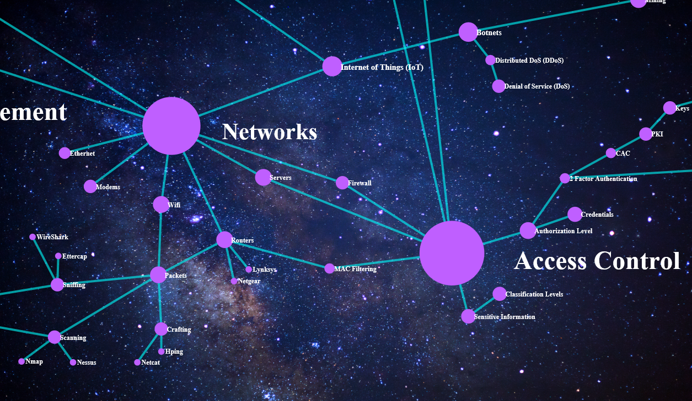

**Figure 2.** Current cyber Topic Map in the CEH™.

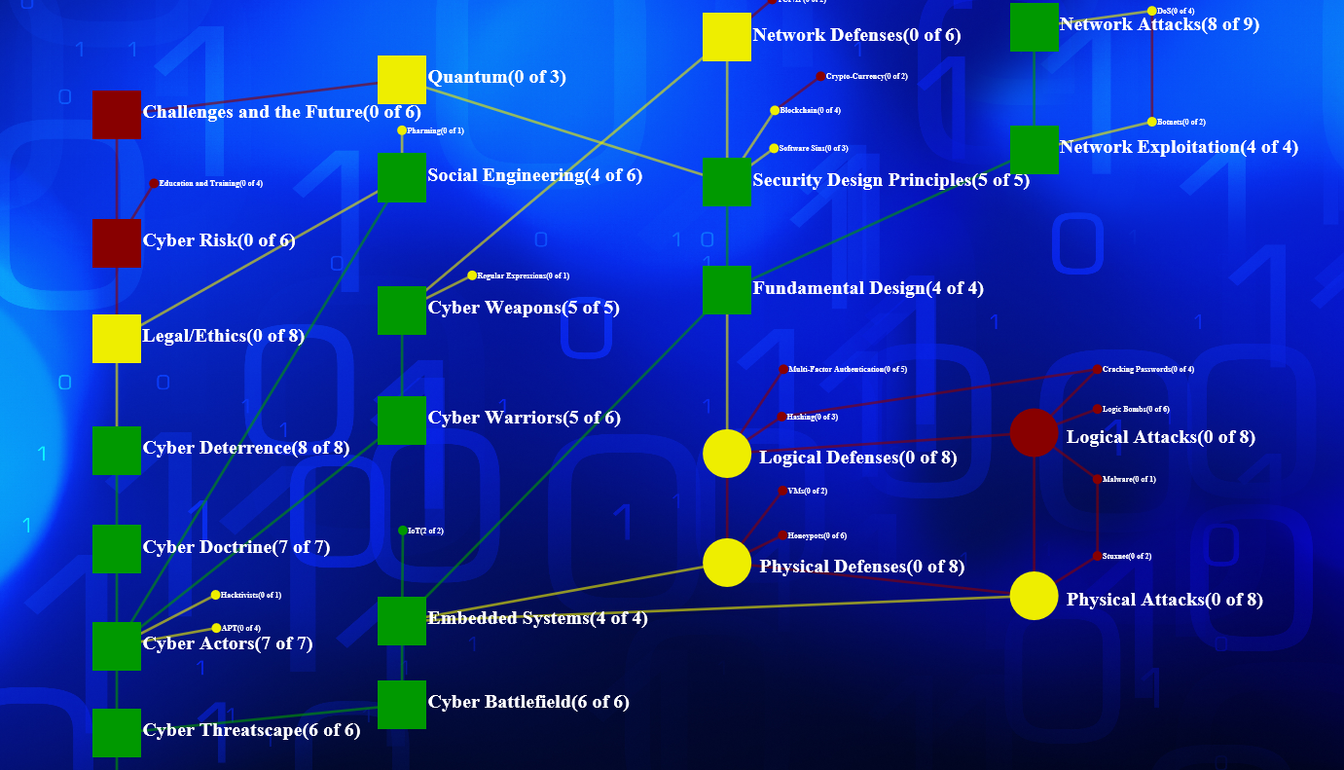

**Figure 3.** A KSA Tree used as part of an AFIT graduate course.

The CEH™ has the potential to advance education and training technology in the USAF and provide input to the implementation of the AF CoL. Following this model, this paper proposes a similar education hub for MDO with a unique focus on MDC2 called the *MDO Hub*. By leveraging past development, design, and research as well as current experimentation on user engagement, the new education system design can focus on elements directly tied to MDO education. This new system would deliver education and training content to warfighters across multiple services and organizations in the DoD focused on synergizing operations from the five major domains.

By design, the MDO Hub would be closely tied to the Cyber Education Hub as cyber is one of the five domains and affects or enables the communication and connectivity between the other domains. Additionally, integrating cyber operations into current C2 systems and determining how cyber acts as both a supported and supporting capability is another immediate challenge facing the DoD. However, simply creating an area in the CEH for MDO education will not accomplish the goal of creating a system for warfighters from all domains to interact because it will be too focused on cyber, which may limit involvement from other domains. Design choices will need to be made to balance the environment across organizations and domains removing barriers to entry for potential learners and content contributors. The current system enjoys significant input by members of the USAF and it its current design is geared for the USAF members, therefore further analysis is required to determine the best design for a DoD-wide audience.

Education resources in the environment must move beyond books, articles, and videos to provide capabilities for users to implement the knowledge they are acquiring and practice the skills necessary to be a warfighter who can understand and effectively implement MDO in their context. This includes hands-on and interactive content and teaching tools accessible to all users. One MDO Hub feature will be a built-in digital card game designed to allow players to build and test strategies as well as show how capabilities from separate domains can be packaged to create advantages on the battlefield. The MDC2 Card Game, built by Alan Lin while at AFIT’s Center for Cyberspace Research, is under evaluation to determine how best to utilize the game to teach MDO concepts. The game has many potential learning objectives. One of objectives identified by Lin and Reith (2018) is that cyber capabilities require steps in the kill chain just like kinetic ones. It is designed for two players to battle each other with a preselected deck of 40 cards covering military capabilities from cyber, land, space, and air domains. However, enhancements could be made in the digital version to allow individuals to test strategies against automated opponents under specified scenarios or even allow multiple individuals or teams to play at once.

Other key elements of the MDO Hub will be a way to track a user’s experience and engagement in the MDO community. By tracking a user’s content consumption and creation, contributions, acquired skills and abilities (such as success in the MDC2 Card Game) and operational experience the MDO Hub could be a single environment for tracking C2 experience and providing robust training. This would fulfill the need expressed by Burdett for MDC2 experience tracking but include much more than just years of experience or positions held but also track what the users has recently consumed and contributed to the MDO community.

**6. Evaluation Strategy and Future Work**

Our strategy for evaluating this proposed environment includes leveraging research conducted using the CEH as well as feedback from DoD personnel from all domains and those already engaged in MDO education to answer the research questions detailed below.

* What MDO content should be provided to learners and how should the initial MDO Topic Map be populated? This research will seek to answer if a virtual, collaborative environment with advanced features like the Topic Map and KSA Trees will enhance user engagement and learning. Future research will summarize and analyze current MDO education courses and solutions across the DoD for best practices. This research could uncover other hands-on or role-playing elements that would be beneficial to the military to produce effective MDO warfighters. Additionally, this research question would consider the subjects or tasks that require KSA Trees. Research opportunities exist to test the response from DoD personnel, from multiple domains and services, to various Topic Maps and KSA Trees. User preferences, content views, the order content is consumed, and perceived usefulness would provide insight into the most effective content.
* What is the effect of aHow should the MDO Hub be organized and structured?What is the effect of a collaborative, digital learning environment on DoD Multi-Domain Operations education?This research questions would explore what specific “channels” should be presented to the user on the MDO Hub landing page. The CEH has defined general categories such as “Popular” and “Recently Added” but there is room for other designators that would be specific to MDO. How these are defined and used by the underlying system to present certain content to various users will flow out of research of the most effective MDO training in existence. Decisions made will affect how deep learners delve into domains other than their operational domain. For example, how much depth does a cyber operator need to be able to understand how to integrate their capabilities with sea or land operations? This research will answer questions concerning what content should be used in an MDO system vice content that is too detailed and should be moved to a system reserved for a specific domain.
* What efforts are needed to spark collaboration on solutions for defensive MDO, specifically base defense? The AF Chief of Staff has described the benefits of MDC2 as overwhelming enemy forces by executing operations for multiple domains at a speed at which they cannot react quickly enough. However, more research is needed to best implement MDO in the arena of military base defense. Military establishments may face coordinated threats from multiple domains and must be ready to respond. Future research in this area could identify key transformations that bring together air, cyber, and physical defense organizations to examine defensive MDO on a micro-level. Timing of this research could prove beneficial as the USAF is in the midst of deploying mission defense teams across the force to focus on local installation and critical mission defense.

1. I like how you ended with open questions. Tailor these to your specific thesis research! If you can swing it, sketch out your thoughts on what you will do and how you will evaluate these questions for your experiment. You’re not bound to do these things, but the goal is to elicit feedback from the conference.

What an MDO specific Topic Map and KSA Trees increase user engagement? What is the effect of a serious game in MDO education of DoD personnel?

**7. Conclusion**

In response to sustained calls for change, the USAF is currently conducting two key transformations in the areas of MDO and education and training. These are happening at a unique time in history when technology is available to effectively and efficiently gather and create education and training content to enable the development of large populations to help prepare them to adapt to future challenges. Addressing the intersection of these two topics, this paper proposed a digital learning environment, called the MDO Hub, to begin to address the concerns and suggested the creation of an experimental prototype providing future research opportunities. The proposed system draws heavily from the framework proposed by Reith et al. and the CEH, a model learning platform built by a team from AFIT’s CCR. Both their system and the one proposed here utilizes concepts from SDL and successful commercial tools and should be used to shape further research and development of the AF CoL. Finally, additional work and research is needed to determine the most effective path forward to educate an agile and effective fighting force with the mindset and experience to wage multi-domain warfare anywhere in the world.

**References**

﻿Alberts, D. S., and Hayes, R. E. (2006) *The Future of Command and Control - Understanding Command and Control*. CCRP Publication Series. Vol. 71. <https://doi.org/10.1353/jmh.2007.0051>.

Caputo, V. J. (2017) “505th Command and Control Wing Hosts Multi-Domain C2 Joint Exercise.” AF.MIL. <https://www.505ccw.acc.af.mil/News/Article-Display/Article/1272361/505th-ccw-hosts-multi-domain-c2-joint-exercise>.

Deterding, S., Dixon, D., Khaled, R., and Nacke, L. "From Game Design Elements to Gamefulness: Defining Gamification." In *Proceedings of the 15th international academic MindTrek conference: Envisioning future media environments*, pp. 9-15. ACM, 2011.

Eddins, J. M., Jr. (2018) "Byte-Size Learning." Airman Magazine. May 8, 2018. Accessed December 31, 2018. http://airman.dodlive.mil/2018/05/08/bytesizelearning/.

Goldfein, D. (2018), “US Air Force Chief of Staff: Our military must harness the potential of multidomain operations.” Defense News. <https://www.defensenews.com/outlook/2018/12/10/us-air-force-chief-of-staff-our-military-must-harness-the-potential-of-multidomain-operations>.

﻿Goldfein, D. (2017) “CSAF Focus Area: Enhancing Multi-Domain Command and Control. . . Tying it All Together.” <http://www.af.mil/Portals/1/documents/csaf/letter3/CSAF_Focus_Area_CoverPage.pdf>

Harris, A. (2018) "Preparing for Multidomain Warfare: Lessons from Space/Cyber Operations." *Air & Space Power Journal* 32, no. 3: 45-61.

Hase, S. and Kenyon, C. (2000) "From Andragogy to Heutagogy," *Ulti-BASE In-Site*.

Knowles, M. S. (1975) *Self-Directed Learning: A Guide for Learners and Teachers*. Oxford, England: Association Press.

Lin, A. and Reith, M. (2018) Multi-Domain Command & Control Card Game Instructions. Version 1.0. Working Paper.

Mattis, J. (2017) “Secretary of Defense Jim Mattis’ House Armed Services Committee Written Statement for the Record,” [online], http://www.politico.com/f/?id=0000015c-9f04-d0 70-a57d-fffe4c600001.

Mattis, J. (2018) Summary of the 2018 National Defense Strategy of The United States of America. <https://dod.defense.gov/Portals/1/Documents/pubs/2018-National-Defense-Strategy-Summary.pdf>.

Pomerleau, M. (2018) Air Force Begins to Roll Out Special Cyber Defense Teams. Fifth Domain: Cyber. <https://www.fifthdomain.com/dod/air-force/2018/12/27/air-force-begins-to-roll-out-special-cyber-defense-teams>.

Reith, M., Trias, E., Dacus, C., Martin, S., and Tomcho, L. (2018) "Rethinking USAF Cyber Education and Training," Proceedings of the 13th International Conference on Cyber Warfare and Security, pp 439-447.

Roberson, D.L., Stafford, M.C. (2017) “The Redesigned Air Force Continuum of Learning: Rethinking Force Development for the Future,” Air University Press, Curtis E. LeMay Center for Doctrine Development and Education.

Tomcho, L., Reith, M. (2018) “Engaging Airmen with Cyber Education and Training.” *Journal of The Colloquium for Information System Security Education*, Winter.

Tomcho, L., Lin, A., Reith, M., Long, D., Coggins, D. (2018). “Applying Game Elements of Cyber eLearning: An Experimental Design.” Air Force Institute of Technology.

1. I think we’ve “promoted” CEH just a bit too much in this paper. Certainly good to use examples, but beware the perception of looking like an advertisement for this “product”.
2. We should comment on Tomcho’s results and then focus on how this will help/harm our MDO education efforts.